Introduction to Database Systems‬‏

Car Insurance Company System

Phase 2

Student id | Student name | Slot
20236106 | Mo’men Osman Mohamed | S1
20236041 | Zeyad Ahmed Ehsan | S1
20236080 | Malek Taha Esmaiel | S1
20236062 | Omar Hafez Ali | S1
20235042 | Mousa Mohamed Mousa | S1
20236133 | Alaa Ahmed Atia | S1

Project 10: Car Insurance Company System - Phase 2
Submission
TA: Ibrahim Gomaa
Title: Car Insurance Company System
Phase: Phase 2 (Software Application + Conceptual ERD + Physical ERD + Implemented Database on MS SQL Server)
Cover Sheet
Project Overview
This document presents the Entity Relationship Diagram (ERD) for the Car Insurance Company System, which manages customer data, car ownership, and accident records. The system allows for customer and Car management, accident tracking, and report generation.

Requirments:

Customers and Cars:
Each customer can own one or more cars, and each car can be owned by more than one customer through shared policies or transfer of ownership. Ownership contracts are tracked by their start and end dates, and the system must automatically remind the customer before the end of the contract period. Each customer provides identifying data such as a policy number and driver's license.
Car Information:
Each car is described by its model, manufacturer, license plate, color, and year. Cars are registered in the system once they are insured and linked to a customer.
Accidents:
When an insured car is involved in an accident, the accident must be recorded in the system with its location, date, severity, and optionally, an insurance amount paid. One car may be involved in multiple accidents, and an accident involves one car and only one. Accidents are always associated with one customer and only one who commits or reports the accident.
Monthly Reporting:
Each month, employees are responsible for documenting accidents in a monthly report, which includes the number of total accidents and total amount paid in claims. Each report is written by a single employee, but one employee can write multiple reports.
Employees:
Employees are system users who sign in to perform administrative functions. Each employee may manage other employees (1:M hierarchy), and is responsible for preparing reports. The system tracks employee information including salary and contact data.

Key Business Rules:

Business Rule 1:
"Each car must be owned by at least one customer at all times."
- Implemented in the diagram:
  - Through the relationship Owns between Customer and Car.
  - Cardinality from Car to Customer is (1,N) which means every car must be owned by at least one customer.

Business Rule 2:
"All monthly reports must be created with valid accident data and match the correct time period."
- Represented in the diagram:
  - MonthlyReport is related to Car_Accident through the Documents relationship.
  - MonthlyReport has Month and Year.
  - Car_Accident has a Date attribute.
Business Rule 3:
"An accident must be documented in exactly one monthly report."
- Implemented:
  - Relationship Documents between Car_Accident and MonthlyReport has cardinality (1,1) on both sides.Which means that each accident is in exactly one report.
Business Rule 4:
"A monthly report must be written by exactly one employee."
- Implemented:
  - Relationship Writes between Employee and MonthlyReport.
  - Cardinality from MonthlyReport to Employee is (1,1).
Business Rule 5:
"A monthly report must document at least one accident."
- Implemented:
  - Relationship Documents from MonthlyReport to Car_Accident has cardinality (1,M), to make sure that at least one accident is documented.

Business Rule 6:
"Each employee may manage several others but is only managed by one person."
- Implemented:
  - Recursive relationship Manages on Employee.
  - Cardinality: One employee (manager) can manage many (0,N), and each is managed by exactly one (1,1).

Business Rule 7:
"Before a customer's ownership contract ends, the system must send a reminder."
Business Rule 8:
"A car cannot be deleted if it is linked to existing accidents or ownership.".
Business Rule 9:
"Accident records may include optional compensation amounts (derived from severity)."
- Represented in the diagram:
  - Attribute Amount_Paid shown as a dashed circle on Car_Accident, meaning it is derived.
  - Severity is also present and is mapped by(High, Medium, Low).
Business Rule 10:
"Each accident must be associated with at least one car and one customer."
- Implemented in the diagram:
  - Commits cardinality fromCar_Accident to Customer(1,N)
  - Involves cardinality from Car_Accident to Car(1,N)
Business Rule 11:
"Employees must sign in to access any system functionality."

Business Rule 12:
"Amount_Paid is derived based on the severity (e.g., low, medium, high)."
- Represented in the diagram:
  - Amount_Paid is a derived attribute in Car_Accident, based on Severity.

Business Rule 13:
"Each car and customer may be involved in several accidents."
- Implemented:
  - Commits cardinality: Customer to Car_Accident (0:N)
  - Involves cardinality: Car to Car_Accident (0:N)

Business Rule 14:
"Each insurance policy must be linked to exactly one insurance provider."
- Implemented in the diagram:
  - Relationship: Provides
  - Cardinality: (1,1) from Insurance_Policy to Insurance_Provider
  - Each Insurance_Policy is connected to exactly one provider.
Business Rule 17:
"Each insurance policy has a start and end date."
- Implemented:
  - StartDate and EndDate are attributes of the Insurance_Policy entity.
Business Rule 18:
"Each insurance policy can include multiple types of coverage and amounts."
- Implemented:
  - The ERD has a weak entity called PolicyCoverageItem.
  - It connects Insurance_Policy to multiple CoverageType /CoverageAmount pairs.
Business Rule 19:
"Each PolicyCoverageItem must belong to exactly one insurance policy."
- Implemented:
  - PolicyCoverageItem includes a foreign key from Insurance_Policy
  - Cardinality: (1,1) from PolicyCoverageItem to Insurance_Policy
Business Rule 20:
"Each insurance provider can provide multiple policies."
- Implemented:
  - Relationship Provides(1:M) from Insurance_Provider to Insurance_Policy
Business Rule 21:
"Each insurance provider has identifying details: name, address, phone number."
- Implemented:
  - Attributes: Provider_Name, Address, Phone_Number are part of Insurance_Provider

Business Rule 22:
"Each insurance policy is assigned a unique policy number and policy ID."
- Implemented:
  - PolicyID and PolicyNumber are both attributes in Insurance_Policy with PolicyID being a primary key and PolicyNumber to have a unique constraint.

Business Rule 23:
"Each coverage item has a type and amount."
- Implemented in the diagram:
  - CoverageType and CoverageAmount are attributes of PolicyCoverageItem
Business Rule 25:
"Each customer must have a unique driver's license number."
- Implemented:
  - Attribute DriverLicenseNo exists in the Customer entity and will have a unique constraint.

Business Rule 27:
"Each customer can own multiple cars, and each car can have multiple owners."
- Implemented:
  - The relationship Owns between Customer and Car is M:N.

Business Rule 28:
"Each accident must occur at a specific location."
- Implemented:
  - Car_Accident has a composite attribute group: Location (City, Street, State)
Business Rule 29:
"Each accident must have a severity level and a date."
- Implemented:
  - Severity and Date are attributes in Car_Accident.
Business Rule 30:
"Each accident has a unique identifier."
- Implemented:
  - AccidentID is a primary key in Car_Accident

Business Rule 31:
"Each car has manufacturer details including model, year, and color."
- Implemented:
  - Attributes: Manufacturer, Model, Year, Color in Car.
Business Rule 32:
"Each employee must have identifying details including name, phone, email, and salary."
- Implemented:
  - Attributes in Employee: Name, First_Name, Last_Name, Phone_Number, Email, Salary.
Business Rule 33:
"Each employee has a unique ID."
- Implemented:
  - EmployeeID in Employee is a unique identifier(Primary Key)
Business Rule 34:
"Each customer must have identifying details including name, address, phone, and email."
- Implemented:
  - Customer includes: Name, Phone_Number, Email, and a composite attribute Address (Street, City, State)

Business Rule 35:
"A customer may be involved in multiple accidents, and each accident may involve multiple customers."
- Implemented:
  - M:N relationship Commits between Customer and Car_Accident
Business Rule 37:
"Each report must have a unique Report ID."
- Implemented:
  - Attribute ReportID is a unique identifier(Primary key) in MonthlyReport

Key System Functionalities
1.Sign In:

Allows employees or system users to sign in to the system using secure credentials.
Entities Used : Employee,Customer
2.Add Customer:

Allows adding a new customer with all required personal and insurance details.
Entities Affected: Customer
3.Update Customer Information:

Allows modification and updating already stored customer information like address, phone number, or license information.
Entities Affected: Customer
4.Delete Customer:
Removes a customer from the system, provided no integrity constraints are violated.
Entities Affected: Customer, Owns, Car
5.Add New Car:
Registers a new car in the system and links it to its owners.
Entities Affected: Car, Owns
6.Update Car Information:
Updates car information, e.g., color, model, or license number.
Entities Affected: Car
7.Delete Car:
Deletes a record of a car from the system, subject to integrity constraints on ownership and accidents.
Entities Affected: Car, Owns, Car_Accident
8.Add Accident:
Records details of a new car accident, date, location, cars involved, and severity.
Entities Affected: Car_Accident , Commits
9.Update Accident Information:
Updates existing accident data when new or corrected data is received.
Entities Affected: Car_Accident
10.View Accident Details:
Displays in-depth information of accidents for individual cars or customers.
Entities Affected: Car_Accident, Car, Customer
11.Generate Monthly Reports for Total Accidents:
Produces monthly reports that give a summary of the number of accidents, total paid figures, and other figures.
Entities Affected: MonthlyReport, Car_Accident, Employee
12.Reminder Before Customer End Date:
Reminds automatically customers whose insurance contract is nearing expiry date, allowing them to renew timely if not renwed this delete customer from database, provided no integrity constraints are violated.
Entities Affected: Customer

ERD Conceptual Diagram (FINAL AFTER TA COMMENT)
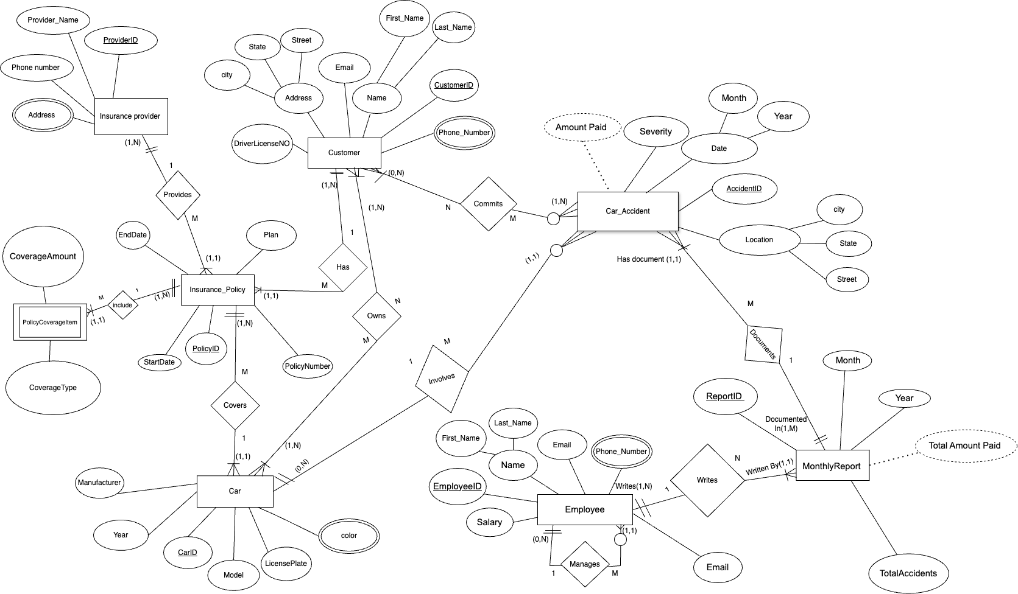

Please read the explanation of the weak entity after our discussion.
Kindly find it below.

ERD Conceptual Diagram (In Power Designer)
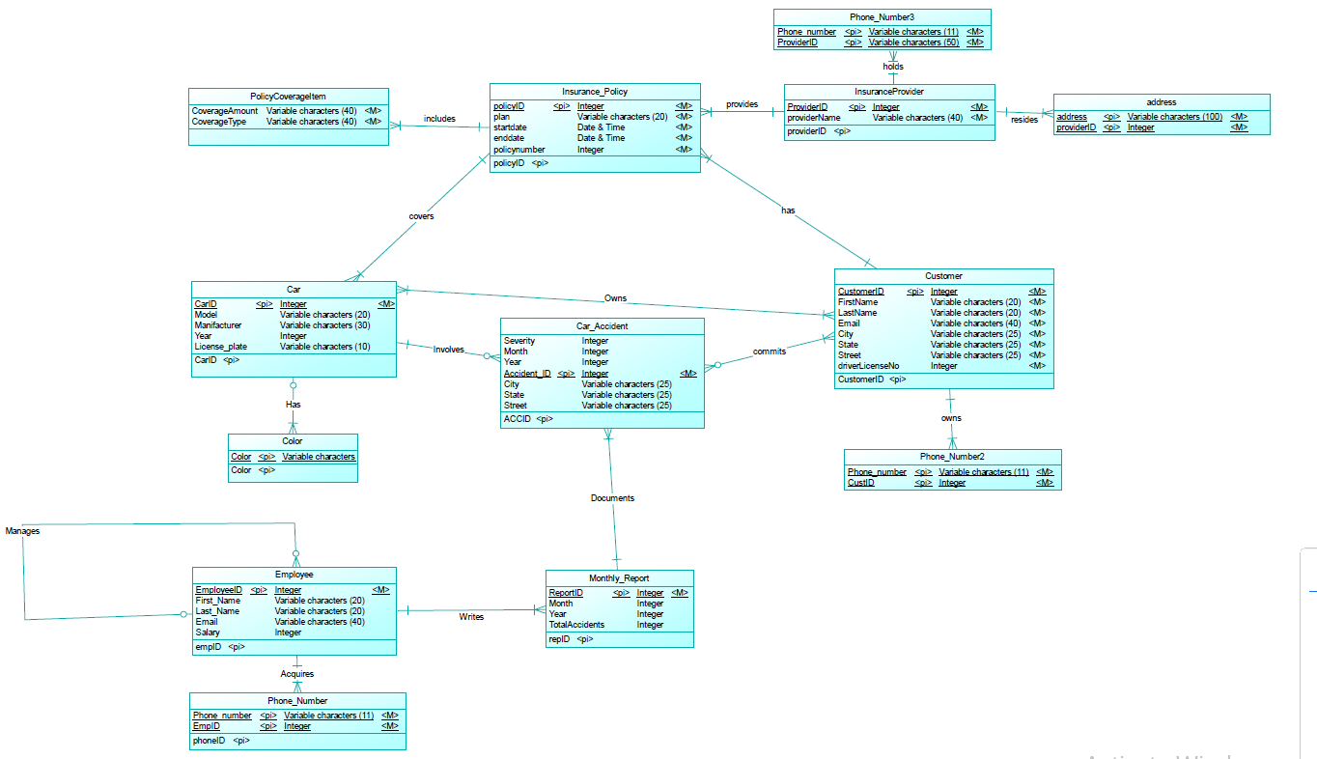

Pysical ERD (In Power Designer)
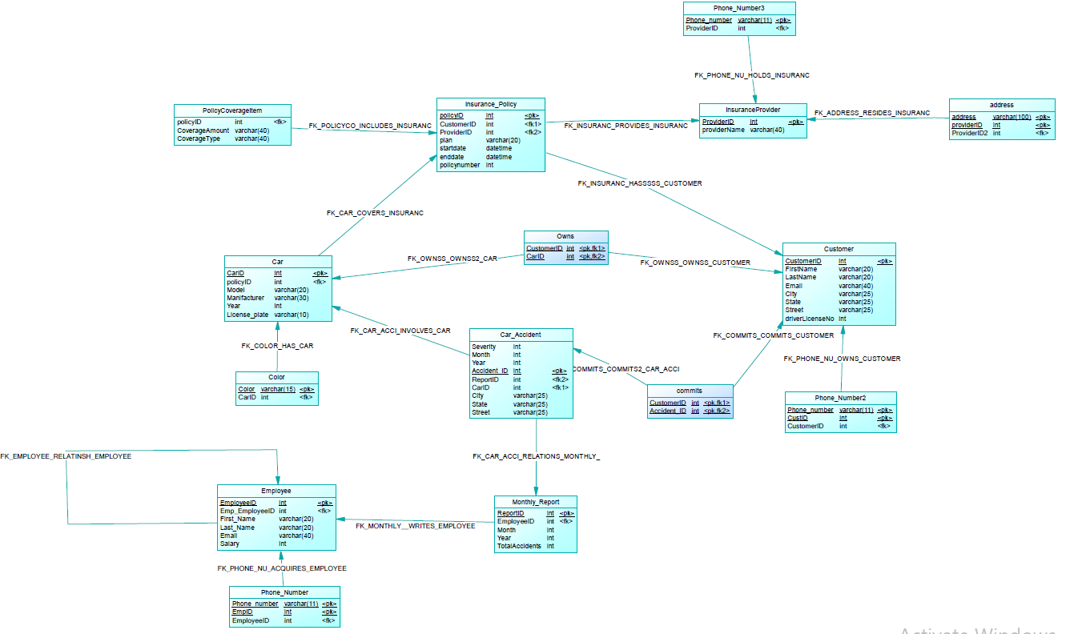

The PolicyCoverageItem entity qualifies as a weak entity because it meets both required conditions:
- Existence Dependency: Each coverage item depends on an associated InsurancePolicy. It cannot exist independently without being linked to a specific policy.
- Partial Key Repetition Across Instances: The same CoverageCode (e.g., C1 for "Collision") can appear in multiple different policies (e.g., P001, P002), just like the example mentioned by TA Ibrahim Gomaa — where two university buildings can each contain a lab with the same name.

Scenario Example:
Policy P001 has:
- Coverage item C1: Collision, $5,000
- Coverage item C2: Theft, $3,000
Policy P002 can also have:
- Coverage item C1: Collision, $6,000
- Coverage item C2: Theft, $4,000
This demonstrates how the CoverageCode is reused across different policy instances, but its full identification requires the parent PolicyID, confirming the weak entity structure.

ERD Conceptual Diagram (BEFORE TA COMMENT)
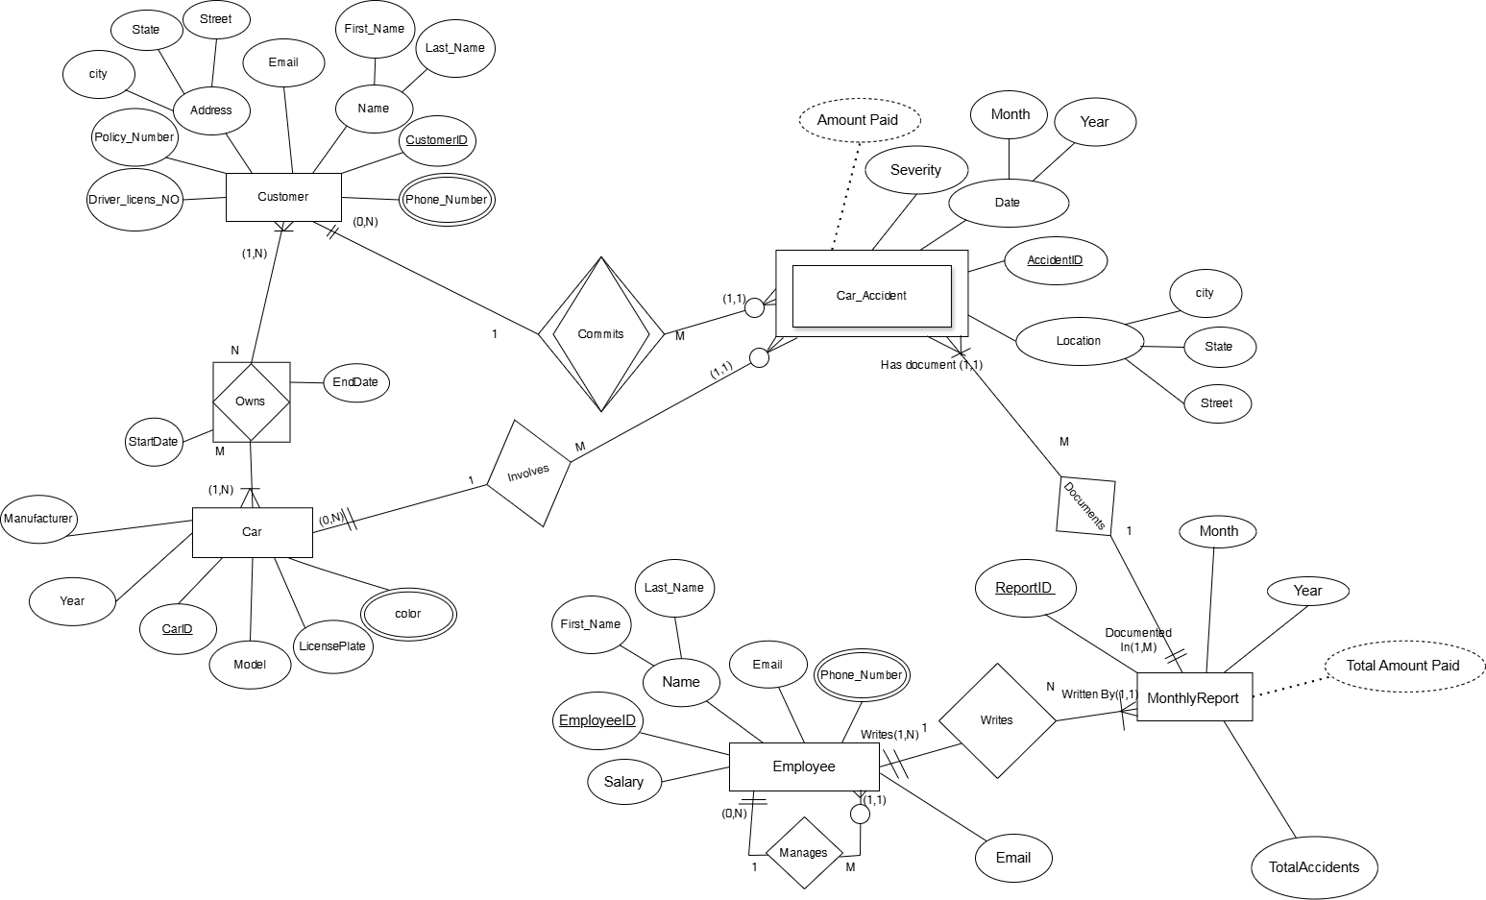

Customer
Attribute | Type | Description
CustomerID | Primary Key (Integer) | Unique identifier for the customer
FirstName | Varchar(20) | First name of the customer
LastName | Varchar(20) | Last name of the customer
Name | Derived | Full name (FirstName + LastName)
Email | Varchar(40) | Customer's email
Street | Varchar(25) | Address street
City | Varchar(25) | Address city
State | Varchar(25) | Address state
DriverLicenseNo | Integer | Driving license number

Phone_Number (Customer)
Attribute | Type | Description
Phone_Number | Varchar(11) | Phone number
CustID | Foreign Key (Integer) | Reference to CustomerID

Car
Attribute | Type | Description
CarID | Primary Key (Integer) | Unique ID for the car
Model | Varchar(20) | Car model
Manufacturer | Varchar(30) | Car manufacturer
Year | Integer | Manufacturing year
LicensePlate | Varchar(10) | License plate
Color | Varchar(15) | Car color

Car_Accident
Attribute | Type | Description
AccidentID | Primary Key (Integer) | Unique identifier for the accident
Severity | Integer | Severity level
AmountPaid | Derived | Amount paid based on severity
Month | Integer | Month of accident
Year | Integer | Year of accident
Street | Varchar(25) | Location street
City | Varchar(25) | Location city
State | Varchar(25) | Location state

Monthly_Report
Attribute | Type | Description
ReportID | Primary Key (Integer) | Unique ID for the report
Month | Integer | Month of the report
Year | Integer | Year of the report
TotalAccidents | Derived | Total number of accidents
TotalAmountPaid | Derived | Total amount paid in the report

Employee
Attribute | Type | Description
EmployeeID | Primary Key (Integer) | Unique employee ID
FirstName | Varchar(20) | First name of employee
LastName | Varchar(20) | Last name of employee
Name | Derived | Full name (FirstName + LastName)
Email | Varchar(40) | Email of employee
Phone_Number | Varchar(11) | Phone number
Salary | Integer | Employee's salary

Insurance_Policy
Attribute | Type | Description
PolicyID | Primary Key (Integer) | Unique policy ID
Plan | Varchar(20) | Plan type
StartDate | DateTime | Policy start date
EndDate | DateTime | Policy end date
PolicyNumber | Integer | Policy number

InsuranceProvider
Attribute | Type | Description
ProviderID | Primary Key (Integer) | ID of insurance provider
ProviderName | Varchar(40) | Name of provider

Phone_Number (Provider)
Attribute | Type | Description
Phone_Number | Varchar(11) | Provider’s phone number
ProviderID | Foreign Key | Associated provider

Address (Provider)
Attribute | Type | Description
Address | Varchar(100) | Full address
ProviderID | Foreign Key | Associated provider

PolicyCoverageItem
Attribute | Type | Description
CoverageAmount | Varchar(40) | Amount of coverage
CoverageType | Varchar(40) | Type of coverage

Relationships
Relationship Name | Type | Description
Owns | M:N | Customer owns car (via associative entity)
Involves | 1:M | Car involved in many accidents
Commits | N:M | Customer commits accident
Documents | 1:M | Monthly_Report documents multiple accidents
Writes | 1:N | Employee writes multiple Monthly_Reports
Manages | 1:M | Manager manages employees (recursive)
Has | 1:M | Customer has one or more policies
Covers | 1:M | Car covered by many InsurancePolicies
Provides | 1:M | Provider provides multiple policies
Includes | 1:M | insurance policy includes many policy coverage items

ERD Tables Summary

Entity Types
Entity Type | Strong or Weak | Attributes
Customer | Strong | (CustomerID, FirstName, LastName, Email, City, State, Street, DriverLicenseNo)
Phone_Number2 | Weak | (Phone_number, CustID)
Car | Strong | (CarID, Model, Manufacturer, Year, LicensePlate, Color)
Car_Accident | Weak | (AccidentID, Month, Year, Street, City, State, Severity)
Monthly_Report | Strong | (ReportID, Month, Year, TotalAccidents)
Employee | Strong | (EmployeeID, First_Name, Last_Name, Email, Salary)
Phone_Number | Weak | (Phone_number, EmpID)
Insurance_Policy | Strong | (PolicyID, Plan, StartDate, EndDate, PolicyNumber)
InsuranceProvider | Strong | (ProviderID, ProviderName)
Phone_Number3 | Weak | (Phone_number, ProviderID)
Address | Weak | (Address, ProviderID)
PolicyCoverageItem | Weak | (CoverageAmount, CoverageType)

Relationship Types
Relationship Type | Between | Cardinality | Participation
Owns | Customer - Car | M:N | Mandatory - Optional
Commits | Customer - Car_Accident | 1:M | Mandatory - Optional
Involves | Car_Accident - Car | M:N | Mandatory - Optional
Documents | Car_Accident - Monthly_Report | M:1 | Mandatory - Mandatory
Writes | Employee - Monthly_Report | 1:M | Mandatory - Mandatory
Manages | Employee - Employee | 1:M | Optional - Optional
Has | Customer - Phone_Number2 | 1:M | Mandatory - Mandatory
Has | Employee - Phone_Number | 1:M | Mandatory - Mandatory
Covers | Insurance_Policy - PolicyCoverageItem | 1:M | Mandatory - Mandatory
Acquires | Customer - Insurance_Policy | 1:M | Mandatory - Optional
Provides | InsuranceProvider - Insurance_Policy | 1:M | Mandatory - Mandatory
Holds | InsuranceProvider - Phone_Number3 | 1:M | Mandatory - Mandatory
Resides | InsuranceProvider - Address | 1:M | Mandatory - Mandatory
Includes | Monthly_Report - Car_Accident | 1:M | Mandatory - Mandatory

